**ASSIGNMENT # 1**



**Spring 2022**

**CSE102 Computer Programming**

Submitted by: **Ali Asghar**

Registration No. : **21PWCSE2059**

Class Section: **C**

“On my honor, as student of University of Engineering and Technology, I have neither given nor received unauthorized assistance on this academic work.”

Student Signature: ______________

Submitted to:

**Dr. Muhammad Athar Javed Sethi**

April 25, 2022

Department of Computer Systems Engineering

University of Engineering and Technology, Peshawar

**Part 1 - Implement 8X1 Multiplexer using if-else structure.**

**Code:**

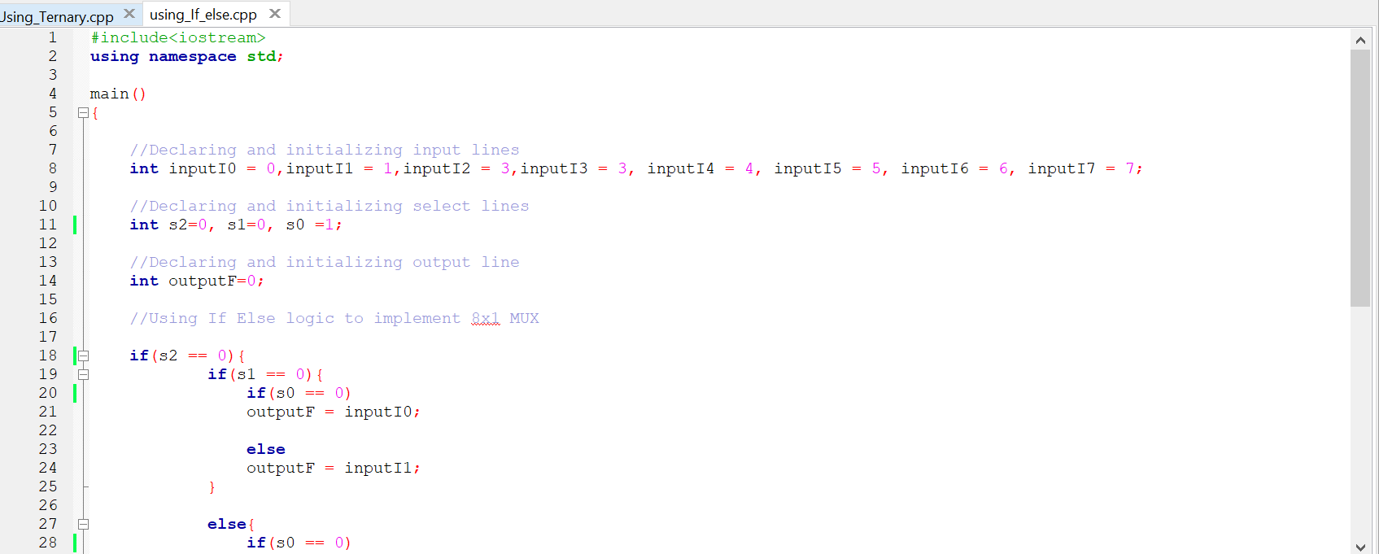

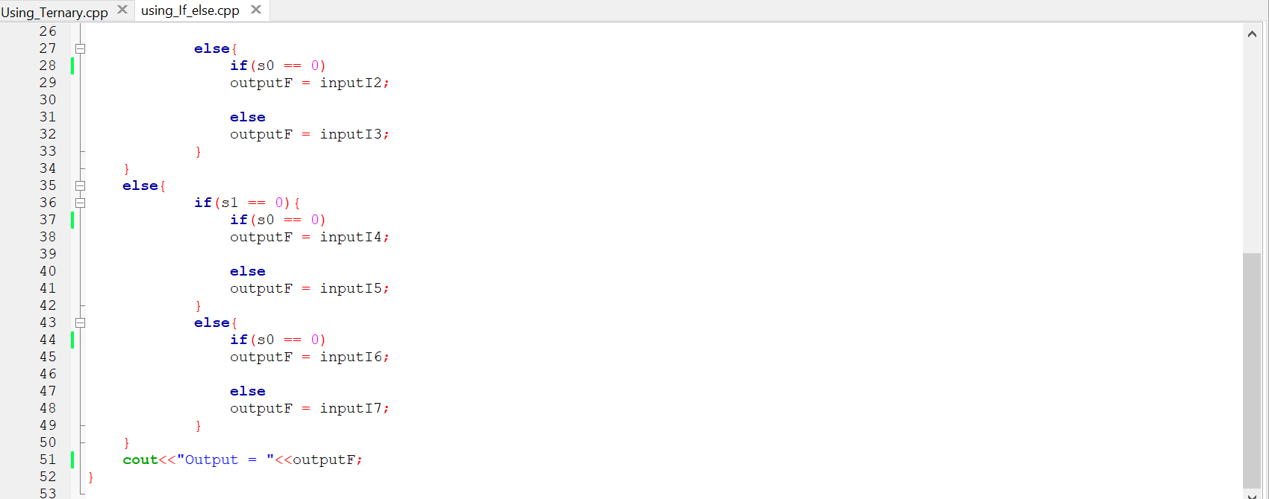

**Output:**

For s2 = 0, s1 = 0 and s0 = 1

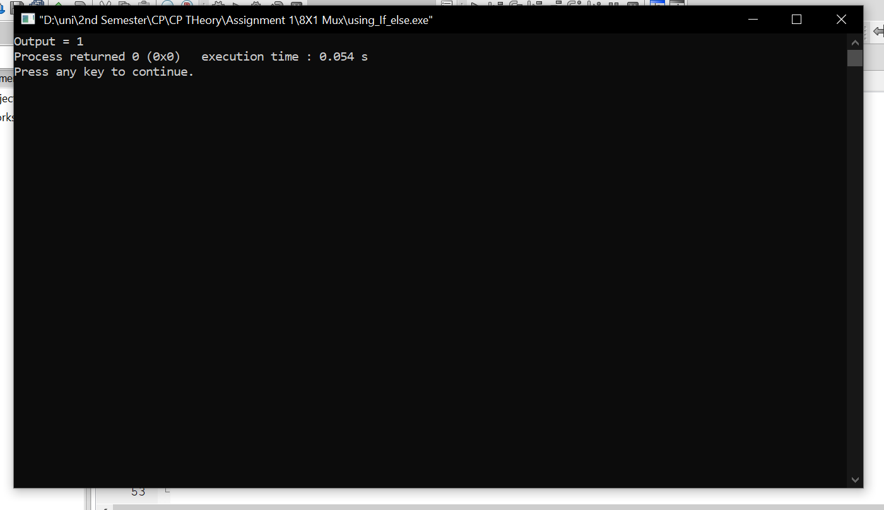

**Part 2 - Implement 8X1 Multiplexer using conditional operator.**

**Code:**

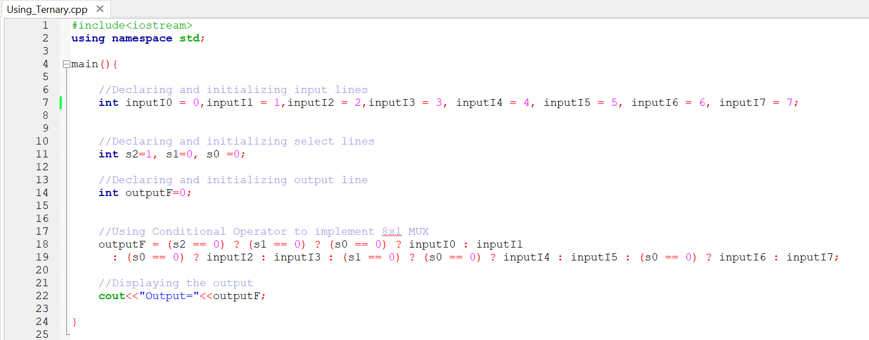

**Output:**

For s2 = 1, s1 = 0 and s0 = 0

